St. David’s Episcopal Church
Beanblossom, Indiana
February 25, 2024 The Second Sunday of Lent, Year B
Sermon by the Rev. Kate Wilson

Genesis 17:1-7, 15-16 Psalm 22:22-30 Romans 4:13-25 Mark 8:31-38

In 1960, a play by Robert Bolt was published titled, A Man for All Seasons. Some years later, a film of the same name was released. It ran for two hours and won six Academy Awards. And at another time, I was tasked with abridging that two-hour play to be enacted within a 45-minute high school class period. I value that assignment because it opened my eyes to a kind of work I loved and would pursue for much of my adult life, and because it introduced me to a single line I have remembered and learn from for all these years since.

The play was an ominous historical drama about England during the 38-year reign of King Henry VIII. And it wasn’t just any time, but the tumultuous years between 1529 and 1535, while Henry VIII made every effort to have his divorce from Catherine of Aragon approved by Pope Clement VII. Henry expected all clergy and members of the court to stand with him in this expectation to be loyal to him and to him alone. Thomas More was the Chancellor of all England, and he did not approve of the divorce nor of a separation of England from Rome. Knowing he faced a charge of treason, More expressed no opinion on the matter at all, choosing to remain silent. Perhaps he could maintain his moral beliefs and his head in this way.

Needless to say, such a stance could not last forever. The court was full of intrigue, of people pledging loyalty no matter what their consciences told them. More remained silent, and was stripped of his title, his wealth, and his significant power. Still, the King wanted More to profess his loyalty aloud, convincing others to follow his lead back to the King. Thomas Cromwell, the King’s henchman, set up a trial, gathered people to speak against More, and to pressure him to buckle. One, an ambitious commoner named Richard Rich, craved a place in the court, its power and wealth, and lied about More, claiming he had heard More speak against the king. Rich’s reward: a large property in Wales.

This long setting of the scene is to get to a line I remember. Thomas More looks at the lying Richard Rich, who has denounced the man he once revered, and said, “For Wales? Why Richard, it profit a man nothing to give his soul for the whole world. . . but for Wales!”
Thomas More cites today’s passage from Mark: For those who want to save their life will lose it, and those who lose their life for my sake, and for the sake of the gospel, will save it. For what will it profit them to gain the whole world and forfeit their life? Indeed, what can they give in return for their life?” And I read that as their soul, their incarnate being. What is worth more than that?

What choices are we making? Are we choosing to live in God’s will, even when it is unpopular? Are we choosing the shiny objects that are so tempting all around us? Are we choosing idols, making gods out of money, success, alcohol, popularity, even cutting other people off at the knees in order to advance ourselves? Are we willing to choose what makes us feel filthy for a few moments of fame? Sometimes we are very willing. But Jesus offers a better alternative, even if he is not delivering it in soft and cooing tones.

Jesus realizes his time is short. His mission is going to be ended. Jesus knows he is a threat to all the powers – Jewish and Roman – and the stakes of their losing power to this attractive prophet are too high to let him continue. Peter is horrified. He rebukes—can you imagine?—he rebukes Jesus. “Hey, Lord, don’t go all negative, talking about death. We’re on a roll with these people! They’re lovin’ us!”

Jesus is beyond patience, riveted to what he needs to say and what we need to hear:
“You are setting your mind not on divine things but on human things.” You are trading your soul for what, Wales? You are drinking yourself to death, or cheating your siblings, for what, a grandfather’s clock, two acres of land? You have detached yourself from the mystery of life and growth and peace for a promotion?
There have been some interesting studies done with babies. If a stranger looks down on a baby with a dead face, expressionless, the baby will, sooner or later, turn away, searching for another face. If another expressionless face appears, the baby will again, look away, and then cry. But if another unknown face appears and smiles, the baby smiles back, may even bubble a bit and laugh. Why? Because we are coded to connect. We are coded to love one another. We are coded to enter into positive relationships. And Jesus taught the ways of building those relationships with one another, with him, and with God.
When we are receptive, we can stretch for the divine, not the things of this world. And not, Rich, for Wales.

Offertory Anthem “Kyrie” Antonin Dvorák
St. David’s Choir
The Offering

The Doxology
As the offering is brought forward, all stand as you are able and sing Hymn #380, verse 3:
Praise God from whom all blessings flow
Praise God all creatures here below
Praise God above ye heavenly host
Praise Father, Son and Holy Ghost! Amen.
The Great Thanksgiving
Eucharist Prayer A from The Book of Common Prayer

The Great Thanksgiving
Presider: The Lord be with you.
People: And with thy spirit.
Presider: Lift up your hearts.
People: We lift them unto the Lord.
Presider: Let us give thanks unto the Lord our God.
People: It is meet and right so to do.

Presider:
It is very meet, right, and our bounden duty,
that we should at all times, and in all places, give thanks unto thee, O Lord, holy Father, almighty, everlasting God.
Through Jesus Christ our Lord;
who was in every way tempted as we are, yet did not sin; by whose grace we are able to triumph over every evil, and to live no longer unto ourselves, but unto him who died for us and rose again.
Therefore with Angels and Archangels, with St. David, and with all the company of heaven,
we laud and magnify thy glorious Name; evermore praising thee, and saying,
Sanctus S114
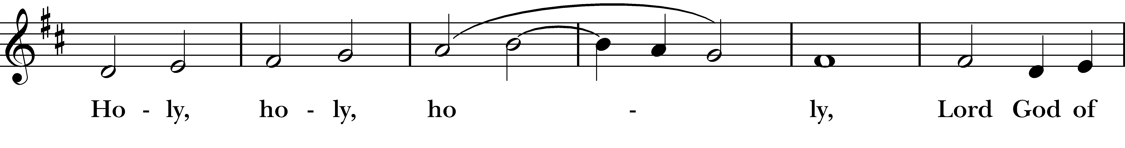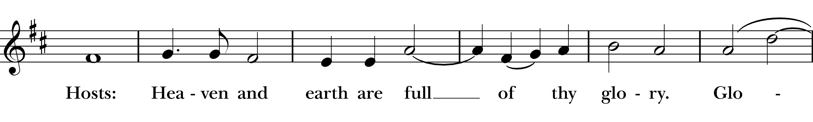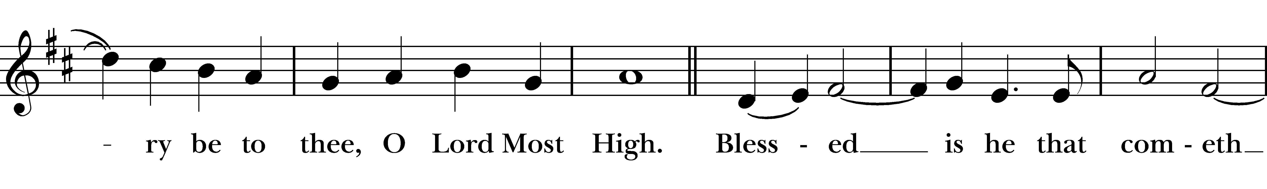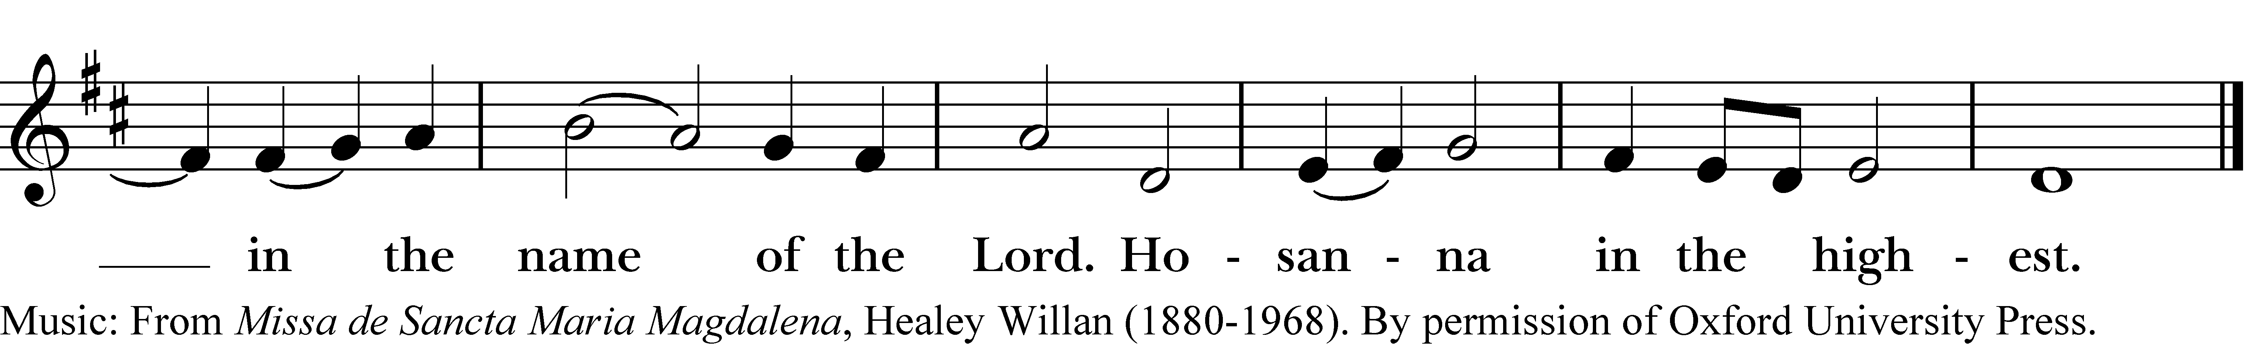
The people stand or kneel.
Then the Presider continues:
All glory be to thee, Almighty God,
our heavenly Father, for that thou, of thy tender mercy, didst give thine only Son Jesus Christ to suffer death upon the cross for our redemption; who made there, by his one oblation of himself once offered, a full, perfect, and sufficient sacrifice, oblation, and satisfaction, for
the sins of the whole world; and did institute, and in his holy Gospel command us to continue,
a perpetual memory of that his precious death and sacrifice, until his coming again.
For in the night in which he was betrayed, he took bread;
and when he had given thanks, he brake it,
and gave it to his disciples, saying,
"Take, eat, this is my Body, which is given for you.
Do this in remembrance of me."
Likewise, after supper, he took the cup;
and when he had given thanks, he gave it to them, saying, "Drink ye all of this; for this is my Blood of the New Testament, which is shed for you, and for many, for the remission of sins.
Do this, as oft as ye shall drink it, in remembrance of me."
Wherefore, O Lord and heavenly Father, according to the
institution of thy dearly beloved Son our Savior Jesus Christ, we, thy humble servants, do celebrate and make here before thy divine Majesty,
with these thy holy gifts,
which we now offer unto thee,
the memorial thy Son hath commanded us to make; having in remembrance his blessed passion
and precious death, his mighty resurrection and
glorious ascension;
rendering unto thee most hearty thanks for the innumerable
benefits procured unto us by the same.
And we most humbly beseech thee,
O merciful Father,
To hear us; and, of thy almighty goodness, vouchsafe to bless
and sanctify, with thy Word and Holy Spirit, these thy gifts
and creatures of bread and wine; that we, receiving them
according to thy Son our Savior Jesus Christ's holy institution,
in remembrance of his death and passion, may be partakers
of his most blessed Body and Blood.
And we earnestly desire thy fatherly goodness mercifully to
accept this our sacrifice of praise and thanksgiving; most
humbly beseeching thee to grant that, by the merits and
death of thy Son Jesus Christ, and through faith in his blood,
we, and all thy whole Church, may obtain remission of our
sins, and all other benefits of his passion.
And here we offer and present unto thee, O Lord, our selves,
our souls and bodies, to be a reasonable, holy, and living
sacrifice unto thee; humbly beseeching thee that we, and all
others who shall be partakers of this Holy Communion, may
worthily receive the most precious Body and Blood of thy Son
Jesus Christ, be filled with thy grace and heavenly benediction,
and made one body with him, that he may dwell in us, and
we in him.
And although we are unworthy, through our manifold sins,
to offer unto thee any sacrifice, yet we beseech thee to accept
this our bounden duty and service, not weighing our merits,
but pardoning our offenses, through Jesus Christ our Lord;
By whom, and with whom, in the unity of the Holy Ghost,
all honor and glory be unto thee, O Father Almighty, world
without end. Amen.
The Lord’s Prayer
Presider: And now, as our Savior Christ hath taught us, we are bold to say,

Our Father, who art in heaven,
hallowed be thy Name,
thy kingdom come,
thy will be done,
on earth as it is in heaven.
Give us this day our daily bread.
And forgive us our trespasses,
as we forgive those who trespass against us.
And lead us not into temptation,
but deliver us from evil.
For thine is the kingdom, and the power, and the glory,
for ever and ever. Amen.

The Breaking of the Bread

The breaking of the Bread represents the death of Jesus on the cross.

Presider: Christ our Passover is sacrificed for us.
People: Therefore, let us keep the feast.

S158 Fraction Anthem: Lamb of God S158
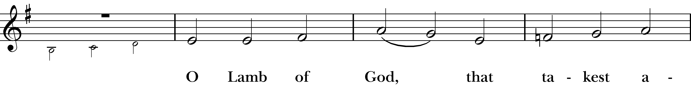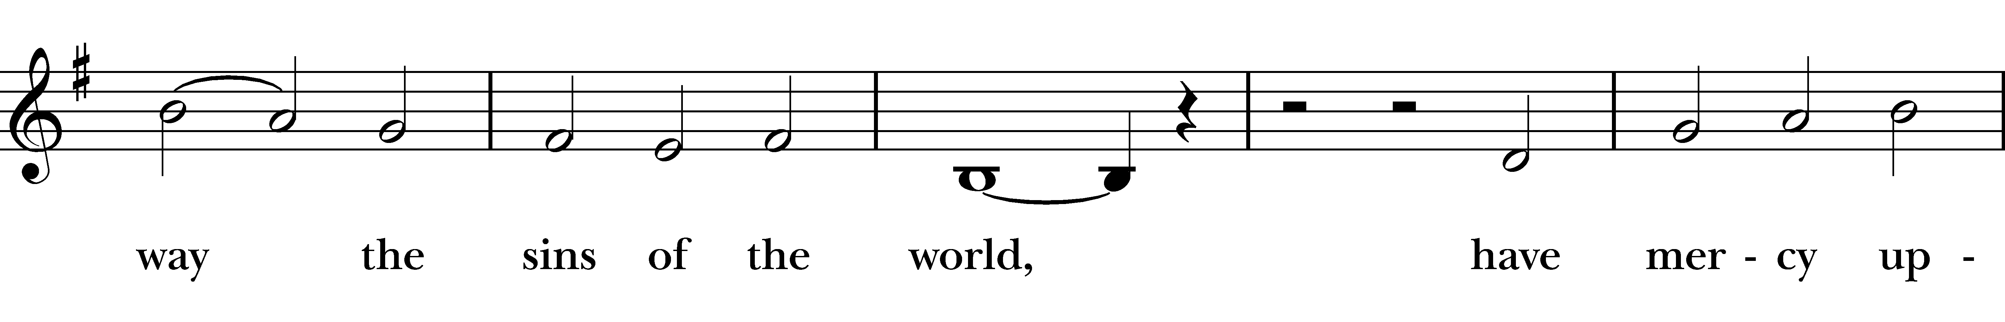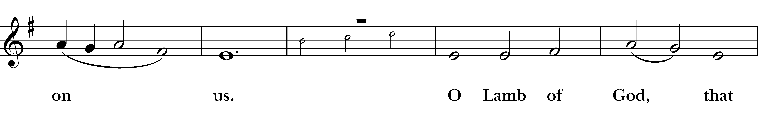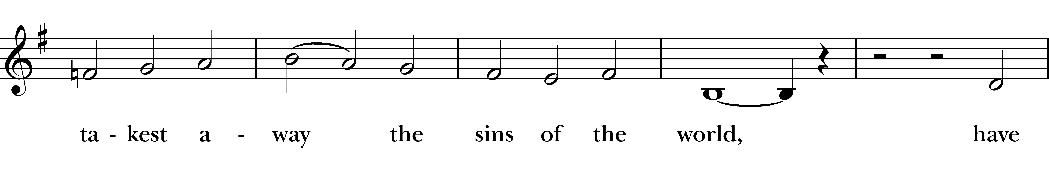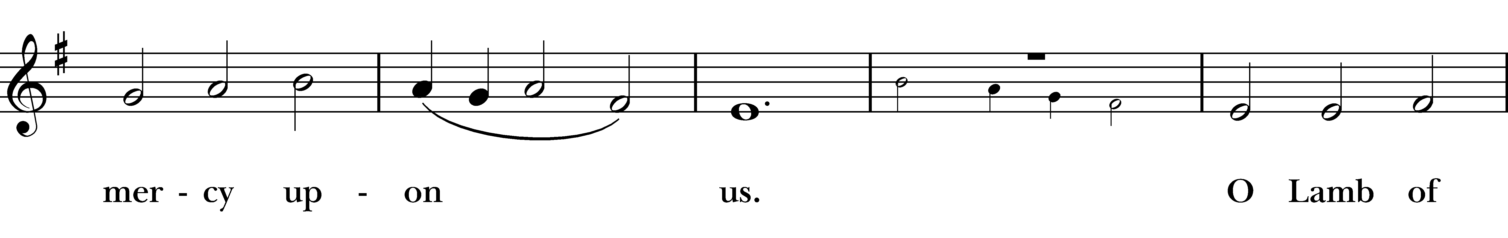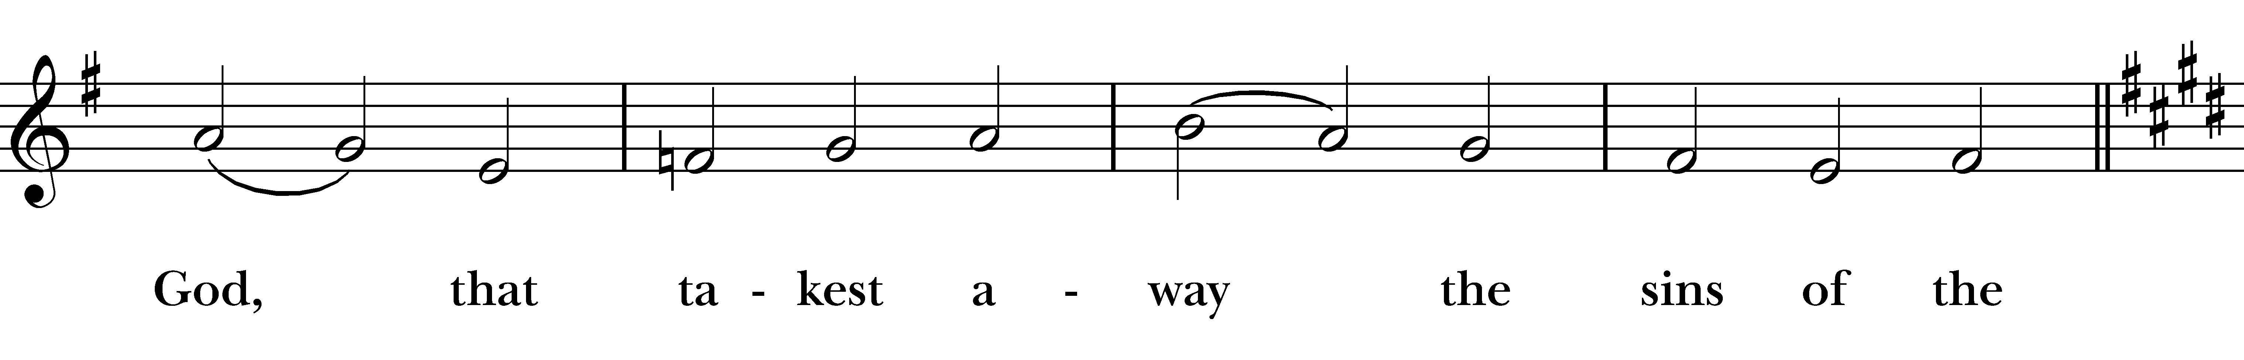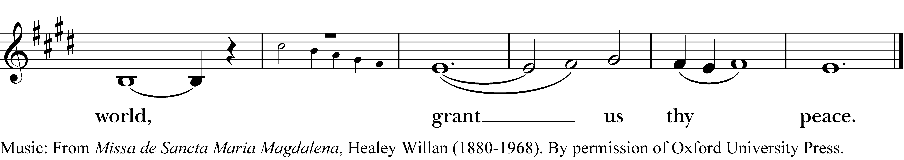
Presider:

We do not presume to come to this thy Table, O merciful
Lord, trusting in our own righteousness, but in thy manifold
and great mercies. We are not worthy so much as to gather
up the crumbs under thy Table. But thou art the same Lord
whose property is always to have mercy. Grant us therefore,
gracious Lord, so to eat the flesh of thy dear Son Jesus Christ,
and to drink his blood, that we may evermore dwell in him,
and he in us. Amen.

The Gifts of God for the People of God. Take them in remembrance that Christ died for you, and feed on him in your hearts by faith, with thanksgiving.

The Communion
All who come in faith are welcome at the Lord’s Table. If you choose not to receive, please feel free to come forward for a blessing by folding your arms across your chest. Gluten-free Communion bread and/or grape juice in the place of wine are also available. To receive gluten-free bread, cup one hand over the other, palms down, as you approach the Presider. The smaller of the two chalices contains consecrated grape juice.

The Bread and the Cup are first given to the ministers and choir and then to communicants with these words:
The Body of Christ, the bread of heaven. Amen.
or
The Body of our Lord Jesus Christ keep you in
everlasting life. Amen.

The Blood of Christ, the cup of salvation. Amen.
or
The Blood of our Lord Jesus Christ keep you in
everlasting life. Amen.

Communion Music “Swing Low, Sweet Chariot” Traditional*
*In honor of Black History Month
Marge Steiner, Soloist
The Post Communion Prayer
Presider: Let us pray in thanksgiving for those here today online, and for one another and this holy sacrament.

Almighty and ever-living God, we most heartily thank thee for that thou dost feed us, in these holy mysteries, with the spiritual food of the most precious Body and Blood of thy Son our Savior Jesus Christ; and dost assure us thereby of thy favor and goodness towards us; and that we are very members incorporate in the mystical body of thy Son, the blessed company of all faithful people; and are also heirs, through hope, of thy everlasting kingdom. And we humbly beseech thee, O heavenly Father, so to assist us with thy grace, that we may continue in that holy fellowship, and do all such good works as thou hast prepared for us to walk in; through Jesus Christ our Lord, to whom with thee and the Holy Ghost, be all honor and glory, world without end.
Amen.

The Solemn Prayer
Presider: Grant, most merciful Lord, to your faithful people pardon and peace, that they may be cleansed from all their sins, and serve you with a quiet mind; through Christ our Lord. Amen.

The Connection Codes: The Blueprint & Tools for Creating the Relationships You Crave Paperback – April 26, 2021, Dr. Glenn & Phyllis Hill (Author), Echo Hill-Vetter (Author)

